**CNN Architecture – Lenet-5**

Yann lecun developed this model in 1998. He took a 32x32x1 image with one channel and applied 6 filters on the top of it (the number 6 came from trial and error). The kernel size he took was 5x5. Then they applied pooling layer on top of that (Average pooling, since max pooling was not developed until then). With size = 2x2 and strides = 2.

Then again they applied the conv layer with 16 filters and 5x5 kernel size. Followed by a pooling layer of size 2x2 with strides = 2. Then they applied Flatten layer. The DNN was applied with 2 hidden layers (120 and 84 nuerons respectively). And since they took MNIST dataset set and hence the output layers consists of 10 nuerons.

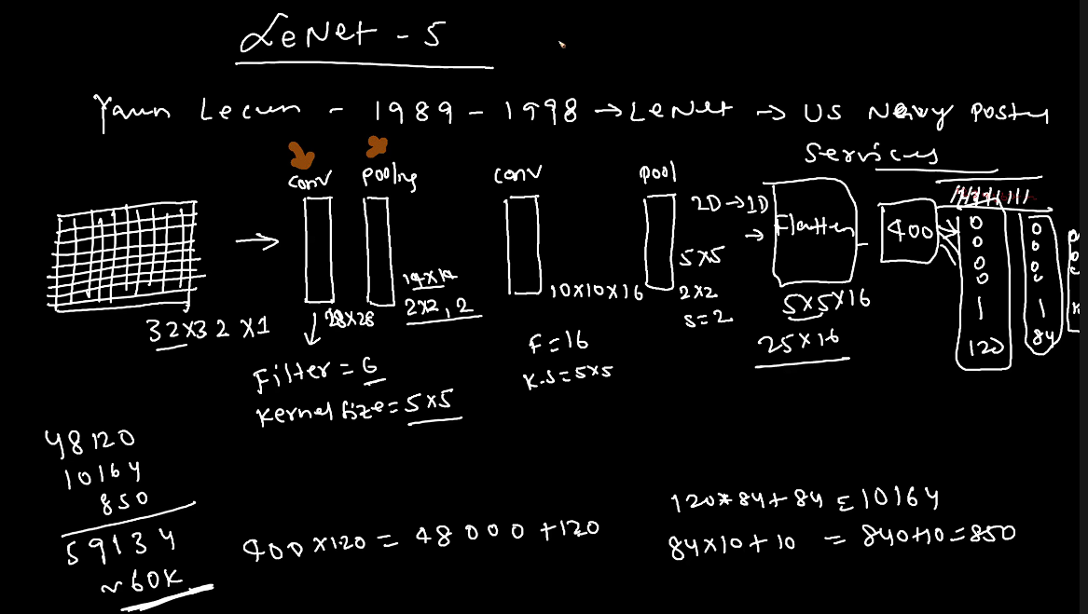

Since it has 5 layers(trainable) hence it is called Lenet-5. We can use this model when we have relatively less number of parameters to be trained around 60k.

